Solidarity story –

A hero – a life for the life

Srđan Aleksić was raising swimming star, as a pioneer, in his hometown Trebinje, south-east Bosnia and Herzegovina. Ordinary, amateur actor from the local Theatre who won several prizes on national level for acting. He was a Serb, having friends among the Muslims, and war (1992-1995) knocked on his door.
His father Rade said…quote:” My Srđo was a benevolent person whom everybody would accept it on the first look. He loved music and, in every situation, he was protecting a week one. As well as he did in this war. He lived little bit bohemian, studying law, but he was not in the hurry, like he knew that he would not need in his life” …end of quote.

Exactly that goodness, in the time of evil, during the war in Bosnia and Herzegovina (ex-Yugoslavia), has shown within its fullness, while creating an example of solidarity and humanity, protecting a fellow Muslim young man in Trebinje.

It was January 21, 1993. The followers of the war evil, having uniforms of the Republika Srpska Army (Serbian Army in BiH), more precisely, military police officers, were asking citizens in Trebinje to show them their ID cards. At one local tavern was sitting a person whose name, for the fascist crazy person as they were, was unimaginable crime. His name was Alen Glavović. A Muslim young man. First, those two police officers, infected by a huge amount of alcohol, started to provoke Glavović, and, after that, took him outside of the tavern, at the market place, where there were waiting for their two other crime brothers.
Srđan Aleksić was there and he stood up against them. They wanted to take him to the prison, but in front of the Police station one of them called “Come over here, balija”and overthrow Alen on the ground when they started to bit him up.
Srđan was standing nearby, aside of kiosk, and he recognized in Alen a person with whom he was working together as a savior at the local swimming pool.

Srđan did not think a second, but immediately came to help Alen Glavović. Srđan did not understand why somebody surname would be enough to be bitten with gunstocks. When he did it, he helped Alen, who successfully escaped, but…so call “soldiers” continued to show the force on Srđan. Strikes of the gunstock were echoing on the streets of Trebinje.
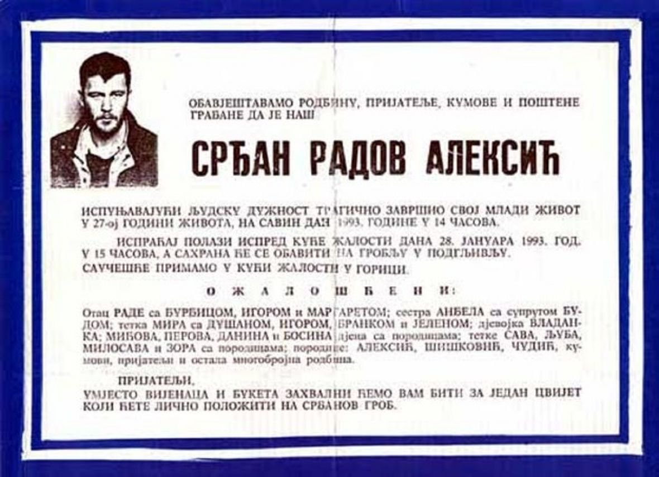
They killled Srđan. One of the murderes was killed during the war, and others were sentenced on 28 months of jail (2 years and 6 months). Nobody knows if those murderers really spent this shame of sentence in jail (it was a war going on).
Alen Glavović lives today in Sweden, he was married and as two children. Every year he comes to Trebinje, visit Srđan grave and his father. He thought his children to be like Srđan.
After death, Srđan was awarded by the Plaque of the Helsinki Committee in Bosnia and Herzegovina and he has a street with his name in Sarajevo, BiH. Also, streets with his name are in Belgrade, Pančevo and one passage in Novi Sad, Serbia and street in Podgorica, Montenegro.
Srđan Aleksić was awarded as well in Serbia, after death, and the medal for courage „Miloš Obilić“ was handed over to his father Rade from President of Serbia in that time, Mr. Boris Tadić back in 2012.
Also, there is a Journalist prize named by Srđan Aleksić
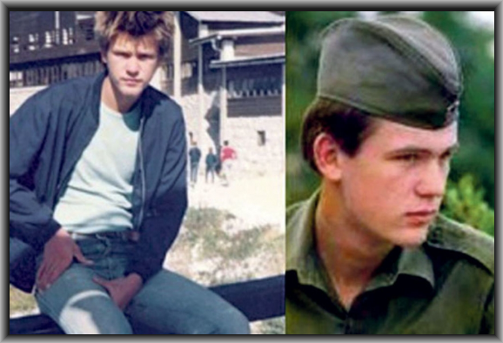
The story of Srđan Aleksić should be a part of the schooling system in the primary school of Bosnia and Herzegovina.
Why?
To represent a person, a hero Srđan who gave life for his friend Alen, protecting him as a human being, within solidarity way of thinking and executing his human task. To help other and different one, although human as he was.

--------------

Author of the solidarity story – translation in English from BHSC – joint language: Bosnian, Serbian, Croatian and Montenegrin by the author

Prof. Sabahudin Hadžialić
Assoc. Prof. Dr. & Dr. Honoris Causa
31.7.2019

Al Jazeera Balkans: http://balkans.aljazeera.net/vijesti/srdan-aleksic-prica-koja-je-oplemenila-mnoge-duse
Details – trailer of the movie CIRCLES (Krugovi): https://www.youtube.com/watch?v=TgaE7y8QjT0
„Balija“ is a bad word for Muslim, and insult of the person.
Info_ IMBD_movie: https://www.imdb.com/title/tt1839522/
Info – details: https://www.youtube.com/watch?v=rnl53Ch3ptA
Info-details: http://hcabl.org/novinarska-nagrada-srdan-aleksic/
Competition for the journalist prize „Srđan Aleksić“: http://efm.ba/2019/05/07/konkurs-za-novinarsku-nagradu-srdjan-aleksic/

