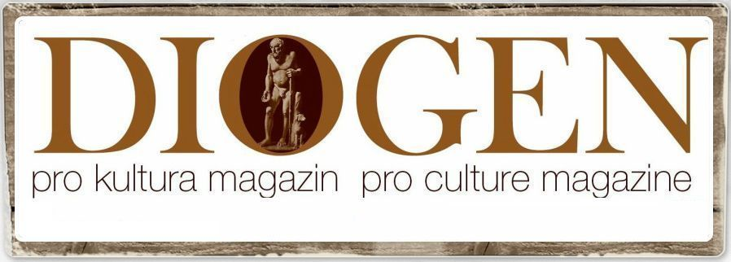
By Peter Tase

Albanian: under the yoke of a communist heritage

Over the last two years, North America and Western European countries have partially failed to inconspicuously understand the roots of infinite corruption, nepotism and proliferation of human and weapons trafficking in Albania. Such a judgmental reluctance towards Tirana’s current ruling class led by Mr. Edi Rama; emerges from the fact that most of his cabinet ministers, although at a young age, have ripped the fruits of Albania’s communist dictatorship and to this day continue to apply a significant level of brutality and ruthless attitude just like their forefathers. Perhaps the international community ought to make an effort to deeply understand the way that Mr. Rama and most of his ministers were raised as well as realize that their previous loyalty to Albanian dictatorship has a direct impact on their current decision making process, even though it appears that Albanian government leadership is embracing Western European values and education and a comfortable lifestyle that is inappropriate considering that their countrymen are the poorest citizens of Europe.
Let’s review some of the prominent communist figures who have direct family ties with Albania’s current ministers, members of parliament and its flamboyant Prime Minister and artist.
Mr. Edi Rama, is the son of Kristaq Rama; a member of Albania’s people presidium (the author of many sculptors of the dictator Enver Hoxha) and is a nephew of Spiro Koleka, a member of the political bureau in the Abanian Labor Party. Mr. Gramoz Ruçi, former member of the Central Committee of Albanian Labor Party and Former Minister of the Interior during the last days of the communist regime.
Namik Dokle, current member of Albanian Parliament, was the editor in chief of Zëri i Popullit, Albania’s largest communist daily newspaper.
Fatmir Xhafaj, secretary of Albanian Socialist Party, former district attorney during communist Albania. Mr. Ilir Gjoni, Albanian Ambassador to Switzerland, is the son of Xhelil Gjoni, member of the Political Bureau in Albanian Labor Party; Mr. Ditmir Bushati, the current Albanian Foreign Minister is the son of Sulejman Bushati, a member of Albanian Labor Party - Central Committee and First Secretary of Labor Party in Shkodër and Kukës. Foreign Minister Bushati has diverted a significant portion of the annual budget from Albanian Ministry of Foreign Affairs towards his own NGO that is currently administered by Mr. Gledis Gjipali.

Mr. Koço Kokëdhima, member of Albanian Parliament since 2013, is the closest adviser of Mr. Edi Rama and Europe’s money laundering expert. He was the first secretary of Communist Youth and is one of the top five wealthiest businessmen in the Balkans, who has amassed his fortune through illicit activities.

Mrs. Mimi Kodheli, member of Albanian Parliament and Minister of Defense; is the daughter of Pjerin Kodheli and Lulzime Kodheli; the latter was a top official in Albanian Labor Party and had studied in Leningrad.

Mr. Ilir Beqja, Minister of Public Health, is a relative to Hamit Beqja, a top official in Albanian Labor Party.

Mr. Arben Çuko, member of parliament, a cousin of Lenka Çuko, a cow milking expert who was a member of the political bureau of Albanian Labor Party. Mr. Qemal Minxhozi, Albanian Ambassador to Kosovo, is the son of Tahir Minxhozi, a member of the Central Committee of Albanian Labor Party.

Mr. Endri Fuga, press secretary and director of communications at the Prime Minister’s Office. Fuga is the nephew of Myqerem Fuga (a minister of the dictatorship regime) and of Shpresa Fuga (a niece of Enver Hoxha) and from his mother’s side is the nephew of Iljaz Reka, former first secretary of the Labor Party in the city of Durrës.

Mrs. Olta Xhaçka, Member of Parliament and niece of Servet Pëllumbi who was the deputy director of the “Vladimir Ilyich Lenin” Labor Party School in Tirana and Speaker of Albanian Assembly.

This is just a background excerpt of Tirana’s current ruling class. The communist roots above are the very reason why Albania remains a developing country, a genuine exporter of communist attitude in Europe and has recently emerged as a nation where an extreme leftist ideology and police state is flourishing; meanwhile its wealthy sheiks (of communist roots) in the government continue to tear apart the socio-economic fabric of its people. Albania’s current leaders are the very same obstacles of progress and legislative reforms in the country. Tirana’s foreign partners should always remember that representatives of North Korea’s leadership replica in Europe may be sitting at the other side of their negotiating table.

PR
DIOGEN pro kultura
http://www.diogenpro.com

