2014.

NOVOGODIŠNJA ČESTITKA

DIOGEN pro kultura magazina

Redakcija Diogen pro cultura magazina zahvaljuje svim pjesnicima na kreiranju ove čestitke. Posebno zahvaljujemo našoj Zamjenici gl. i odg. urednikaTatjani Debeljački, Saši Važić i dr. Tomislavu Maretiću na pomoći pri prikupljanju i prebacivanju poruka od haiku prijatelja. Želimo Vam mnogo uzbudljivih AHA- haiku trenutaka u Novoj godini, te mnogo uspjeha u daljnjem radu.

2014

NEW YEAR GREETING CARD

DIOGEN pro culture magazine

Editorial board would like to express gratitude to all poets who helped in creation of this greeting card. We express special gratitude to our Deputy editor in chief Tatjana Debeljački, to Mr. Saša Važić and dr. Tomislav Maretić on their kind assistance in forwarding messages and collecting the New Year haiku from their haiku pals. We wish you all many exciting AHA- moments in the New Year, and much success in your work.

Željko Funda

kraj godine
nakon kupanja u bari
pas stresa kapljice

the end of the year
after swimming in the pond
the dog shakes the drops off

Rudi Stopar
Sunce daruje
svake nove godine
staro spoznanje

Each New Year
the sun presents us with
and old recognition

Translated by the author

Maria Tirenescu

opening window –
first snow of the New Year
white and cold
flush my face
and clears my thoughts

deschizând fereastra –
prima zăpadă a Anului Nou
albă şi rece
îmi îmbujorează faţa
şi îmi limpezeşte gândurile

otvaram prozor –
prvi snijeg u godini
bijel i hladan
ispire moje lice
i bistri misli

Zoe Savina

" *¨`*•♫
Πρωτοχρονιά
Μικρέ μου χρόνε καμαρώνεις, μα δεν ξέρεις -κοίτα Άγγελοι
διπλώνουν σαν ραφτάδες το χιόνι της ήβης σου

New Year’s Day

my little new year
you gloat but ignore
-behold, angels
folding your puberty’s dew
like skillful tailors
English translation: Constantine Fourakis

Khurshid Alam

I wanna reverse
resolutions to turn them
positive this year.

Želim obrnuti
Odluke i promijeniti ih
na pozitivno ove godine.

Carole MacRury

in the new year--
last year’s resolutions
. . .recycled

u novoj godini–
lanjske rezolucije
… reciklirane

Jacek Margolak

my old pick up
wipers can't keep up with
the New year's rain

moj stari kamionet
brisači posustaju pod
novogodišnjom kišom

Cezar-Florin Ciobîcă

New Year's Eve -
even the saints from the icon
taste the champagne

Silvestrovo -
i sveci na ikoni
kušali šampanjac

Kristina Mojzeš

At crowded square sound
of common hope - midnight bell's
announcing new year
Prepun trg i zvuk
nade- ponoćno zvono
najavi Novu

Translated by the author

Goran Gatalica

tutnje jahači
kasno noću po nebu
gle, meteori
roaring riders
over the sky late at night
look, the meteors

14. Melničke večeri poezije, Melnik, 2013.

Steven Clarkson

Old men talk on –
no time to hope or grieve for
another year
Starci pričaju dalje –
nema vremena, nema nade ili tuge za
još jednu godinu

George Held

Pond
frog jumps in – even
on New year's Day

Ribnjak
žaba uskače – čak
i na Novu Godinu

Joanna M. Weston

He vacuums
behind the TV
New Year

On usisava prašinu
iza televizora
Nova Godina

Ecaterina Neagoe

Santé.
Vos rêves devenir vrai !
Bonne Année !

Health.
Your wishes come true!
Happy New Year!

Zdravlje.
Ostvaruju se tvoje želje!
Sretna Nova Godina.

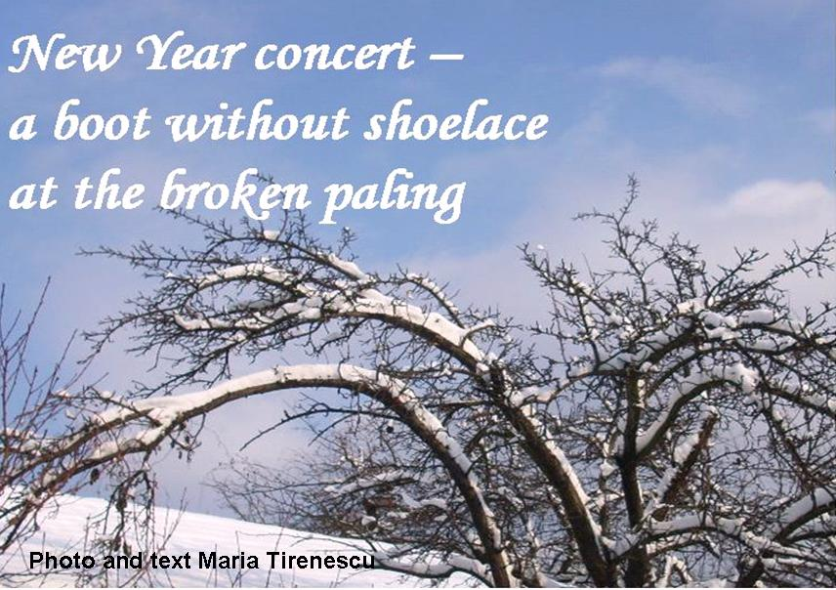Maria Tirenescu

Štefanija Ludvig

u 2014
novi prijatelji
u mom srcu

in 2014
new friends
in my heart

Translated by Vladimir Ludvig

Pera Čikarić
Nova godina.
Zalud kroz prozor viri,
promrzli vrabac.

New Year’s Day.
Gazing through the window in vain
chilled to the bone sparrow.

Michael Dylan Welch

New Year’s Day—
the fresh snowfall
as white as my diary

Nova godina–
tek pao snijeg
bijel poput mog dnevnika

Stella Pierides

first dawn...
slow drip of last year’s
snow

prvo svitanje…
sporo kapanje lanjskog
snijega
Milivoj Kostić Kole

Zalepila se
Na prozor galerije
Prva pahulja.

Stuck to
The gallery’s window pane
The first snowflake.
Vilma Knežević

Sva zrna radosti
Griju nas u
Novogodišnjoj noći

The grains of joy
Warming us
In the New Years Eve

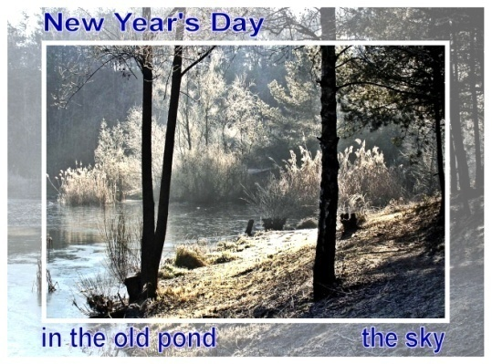Christa Beau

Don Wentworth

tick ticking
just as loud
New Year
Memory

kucanje otkuckava
jednako glasno
Novu Godinu
Sjećanje

Stanka Boneva

All of us at home
smell like honey cookies.
New Year’s Eve.

Svi smo doma
miriši poput medenih kolačića.
Novogodišnja noć.

Nada Zidar-Bogadi

Bjelinu polja
Čini stvarnom tek dim
iz male kolibe.

Whiteness of a field
made real only by the smoke
from a small cabin.

Haiku World An International Poetry Almanac, W. J. Higginson, 1996.

Translated by the author

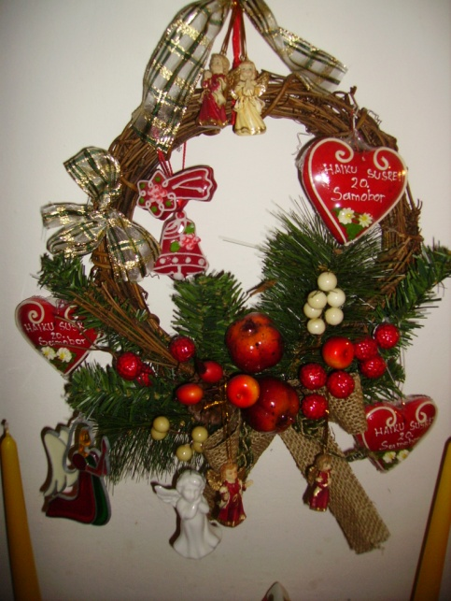Nada Zidar Bogadi

Ante Mate Ivandić

novogodišnje jutro
graktanje vrana remeti
spokoj svitanja

at the new year's morning
the crow's croaking interferes
with a calm of the dawn

Translated by the author

Gerd Börner
am Neujahrsmorgen
alte Schritte gefroren –
ihr Lächeln schaut mir nach
New Year’s Day
yesterday’s steps frozen –
her smile looks after me

Nova Godina
jučerašnje zamrznute stope –
traži me njen osmijeh

Ljiljana Dobra

dva labuda leže
na smrzloj travi
inje se topi

two swans are lying
on the frozen grass
the white-frost is melting

Translated by the author

Neelam Dadhwal

winter jasmine...
after making to the shot day
benign talks

zimski jasmin…
nakon Nove Godine
blagi razgovori

op. a. Meaning: Winter jasmine flowers have no scent but grow abundantly during winters. Here I referred the New Year to "the Shot day" when we pompously display our year-long achievements and great resolution to carry it further, preferably in much better way and pace but as the winter jasmine flower with no scent we slowly start tender talk (the benign talks) and let the things take shape with time.

Fatima Atash Sokhan

Bring spring’s fragrances
house cleaning of my Christian neighbor
in the middle of winter
Mirise proljeća donosi mi
čišćenje kuće mog kršćanskog susjeda
usred zime

Nourouz, Iranian New Year, is in the 21th of March in the spring and we do house cleaning every year for spring coming. House cleaning of my Christian neighbor in these days reminds me Nourouz and spring coming.

Iranska Nova Godina je 21.ožujka, u proljeće i tada mi čistimo naše kuće svake godine za dolazak proljeća. Čišćenje kuće mog susjeda kršćana u ovo vrijeme podsjeća me na dolazak proljeća.

Zlata Bogović

Otkucava ponoć
na vrhu jelke sjaj
Nove Godine

Midnight ticking
on the top of the X-mas tree glistens
the New Year

Marija Horvat Milardović

snijegom prekrita
crkvica na vrh brijega
sjeverac huči

covered by the snow
a small church on the hilltop
roaring North wind

Vasa Radovanović
Niz plavo nebo
jato zvezdanih riba
lagano plovi

Down the blue sky
a flock of starry fish
sailing slowly

Samar Ghose

New Year
just like that
in a tick
Nova Godina
tek tako
u jednom otkucaju

Rita Brgić Stokić

Bljeskaju zvijezde
u naručju zaspala
Stara godina...

Twinkling stars
in my embrace fallen to sleep
the Old year..

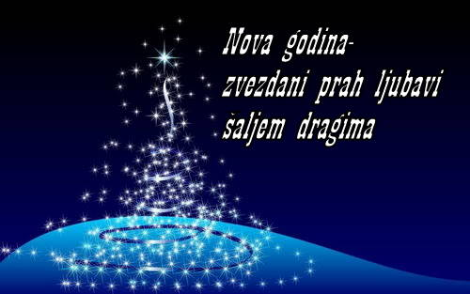Mirjana Ranković Matović

Jasmina Mužinić

U kristalnim čašama
pjenušavo vino priziva
sretnu Novu godinu
In crystal glasses
a sparkling wine evokes
happy New Year

Translated by the author

Ralf Bröker

year's first sunrise
boys laugh while searching
firework
prvo svitanje
dječaci se smiju dok traže
ostatke vatrometa

Wiesław Karliński alias Wilhelm Karud

the last few minutes -
from Alloway to Sydney
auld lang syne

posljedje minute –
od Allowaysa do Sydneya
Auld lang syne*

Auld Lang Syne is a Scots poem written by Robert Burns in 1788 and set to the tune of a traditional folk song
Pjesma Roberta Burnsa iz 1788.g., uglazbljena, postoji više teorija o tome što točno znači auld land syne, moguće da se odnosi na stare (zaboravljene) prijatelje

Ferris Gilli

sunset fires fading
as I finish my barn chores
on the year's first day
a grackle cracks the ice
in a watering trough

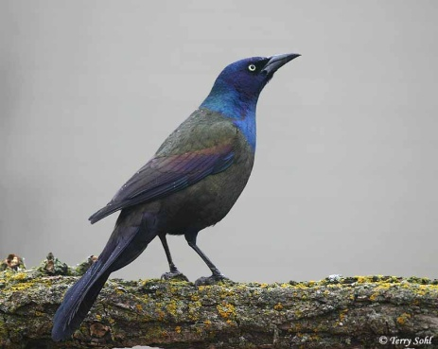 A common grackle
http://sdakotabirds.com/species_photos/common_grackle_2.htm

vatre smiraja blijede
dok završim stajske poslove
na prvi dan godine
vrana razbija led
na pojilištu

Francesco de Sabata

New Year’s white morning –
sparrows outdoors looking
for past year’s crumbs

bijelo novogodišnje jutro –
vrapci u potrazi
za lanjskim mrvicama

Vladimir Ludvig

prasak iskri
dobre želje na nebu
u 2014.

burst of sparks
good wishes on the sky
in 2014

Translated by the author
Hidenori Hiruta

first dream
flying a kite overseas
New Year’s Day

prvi san
puštam zmaja preko mora
Nova godina
Vasile Moldovan, Romania
The first New year's dream:
A flock of white doves circling
Above the blue Danube
Novogodišnji san;
Jato bijelih golubica kruži
Nad plavim Dunavom
M. Kei

a fresh leaf
white in the winter
of a new year;
it seems a shame
to mar it with words

svjež list
bijel zimi
o novoj godini;
ispada da je sramota
nagrditi ga riječima

January, A Tanka Diary. Perryville, MD: Keibooks, 2013.

Foroogh Foroutani
Chikens in the nest
Where is Jesus’ breath?
Open mouth all

Pilići u gnijezdu
Gdje je Isusov dah?
Otvorena sva usta

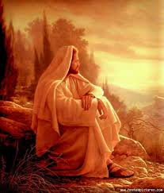
Božidar Škobić Čika Boško
Stari ogrtač,
Stare čizme –
Novu godinu
zbrinut čekam.

An old cloak,
Old boots –
I wait for the New Year
well taken care of.

Helen Buckingham, England

day one of the fast--
the image of Ganesha
stuck to my fridge

(Frogpond, 31:3, 2008)

prvi dan posta –
slika Ganeshe
pričvršćena na frižider

Lord Ganesha as the blend of human and animal parts (head of an elephant) symbolizes the ideals of perfection as conceived by Hindu sages and illustrates some philosophical concepts of profound spiritual significance. Hindus worship Ganesha first before beginning any religious, spiritual or worldly activity. (http://www.koausa.org/Gods/God8.html)

Ganesha ili Ganapati, popularan indijski Bog s glavom slona, štuje se prije svakog početka nekog poduzimanja.

Vitali Khomin

New Year's rain
a weasel cleans carefully
new fur coat on a porch

Novogodišnja kiša
na trijemu lasica pažljivo čisti
nov krzenin kaput

zohreh zahedi

New Year’s morning…
mother’s dropsical eyes
on the rag dolls

novogodišnje jutro...
majčine otečene oči
na krpenim lutkama

Silva Trstenjak

u novu godinu
kotrljamo se na
čepu od pjenušca

into the new year
we roll on
the champagne cork

Frank Dullaghan

Midnight –
hanging a new calendar
above my desk
ponoć –
vješam novi calendar
iznad svog radnog stola

Tomislav Maretić

prva svjetlost
na krilima labudova
Nova godina

a first light
on the wings of swans
New years day

Translated by the author

Dinko Sule

božićno svjetlo
željama za voljene
obasjava put

Christmas light
on the wishes of loved ones
lights the way

Dunja Pezelj

Poslije slavlja,
iz sjaja u smetlište
ukrasno drvce.

After the party,
from splendor to dump
the X-mas tree.

Tugomir Orak

Umjesto suza
niz lica teku zvijezde.
Nova godina.

Instead of tears
the stars flow down the cheeks.
The New Year’s Day.

Ljubomir Radovančević

Starci na
Mostu mladosti čestitaju si
Novu Godinu

Two old men
Congratulate each other the New Year
On the Bridge of Youth

Harvey Jenkins

comfortable saddle
the New Year begins
with an easy canter

udobno sedlo
Nova godina počinje
lakim galopom

*Prema kineskom kalendaru, 2014.je godina konja

Jadranka Vučak

Na cesti se
gase prskalice pred
zaljubljenim parom

on the street
in front of an couple in love
extinguishing spargers

Milena Mrkela

iako ukrašeno
novogodišnje veče
sasvim obično
dok ne udje s naramkom drva
i osmjehom

although adorned
this New Year’s Eve
just like any other
until he enters with an armful of wood
and his smile

Tatjana Stefanović

nikog sem vetra.
novogodsinju tortu
trpam u sebe.

no one except the wind
I'm cramming the New Year cake
into myself
Translated by Saša Važić
Angelo B. Ancheta

the column of sparks
from the fountain rises
on New Year's eve
how do I start this time
with an end

stup iskrica
uzdiže se iz fontane
u novogodišnjoj noći
kako da započnem ovaj put
sa svršetkom

Willie Bongky

New Year's Day
the dining table without
twelve rounded fruits

Nova Godina
trpeza bez
dvanaest vrsta okruglog voća

Nikola Šimić Tonin

Nova Godina,
mladice duše vjere
Blagdanska svjetla.
New Year’s Day,
soul’s sprouts of the faith
The lights of holidays

Miroslav Mišel Boltres

Dani godine:
Tristašezdest i pet
- Svaki za sebe!

Days of the year:
Threehundred sixty five
- Each on his own!
Evgeny Ivanov
garland lights
two bulbs blink
out of time
lampice na božićnoj jelki
dvije žaruljice trepere
izvan ritma
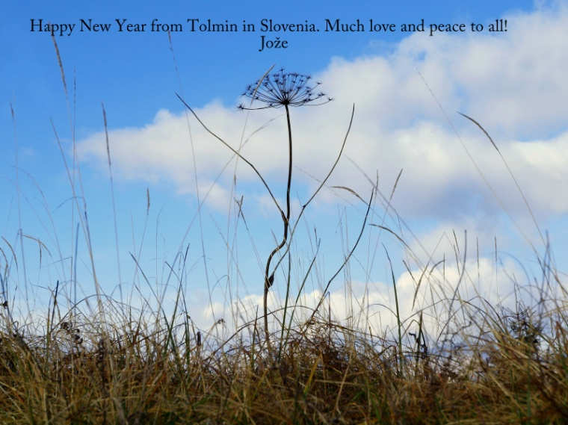Jože Štucin

Gordana Radovanović

Crvene čizme
prave prtinu nebom.
Za njima zvezde.

The red boots
making a path in the snow over the sky.
Followed by the stars.

Radhey Shiam

birds chirps
an awakening song
to greet the new year dawn
I enjoy the golden splendor
on shower of pearls

ptice pjevaju
budnicu
pozdravljajući novogodišnju zoru
uživam u zlatnom sjaju
obasut biserjem

Jovanka Božić
Ukras na jelki
Svetli najlepšim sjajem
Njegovog oka.

Christmas tree ornament
Glows in the most beautiful shine
Of His eye.

Translated by the author

Diana Teneva

our eyes gazing at
the New Year’s fireworks
even the stars beyond
the Milky Way whisper
blessings for all of us

promatramo
novogodišnji vatromet
čak i zvijezde iznad njega
Mliječna staza šapće
blagoslov za sve nas

Jerjej Kusterle

Edini večer,
ko stojim v dveh letih
ob istem času.
New Year`s Eve,
I stand in yesterday and tomorrow
at the same time.
Translated by the author

Slavica Grgurić-Pajnić

pokrivena noć
željama i nadom
nove godine

noćni nemiri-
tisućama svjetiljki
nova nadanja.

gillena cox

through the church window..
prayers of the faithful mix in with
draught of year’s newness

kroz prozor crkve…
molitve vjernika pomiješane s
novogodišnjim početkom

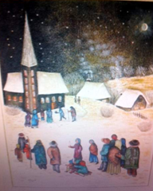Ponoćka
Slava Blažeković

Sonja Kokotović

Otkucava sat:
pored mene svi dragi
Dobrodošla, uđi

Ticking clock:
by my side only dear people
Welcome, come in

Angelo B. Ancheta

the column of sparks
from the fountain rises
on New Year's eve
how do I start this time
with an end
stup iskrica
diže se iz fontane
u novogodišnjoj noći
kako početi ovaj put
s krajom

Smilja Arsić

Увек доноси
наду и бљештавило -
Нова Година!

It`s always bringing
a hope and brilliance -
a Happy New Year!

Translated by the author

Jasminka Predojević

Božićna ponoćka
treći put van-unutra
iste štiklice

Christmas midnight service
for the third time they enter and exit
the same high heels

Angelee Deodhar

New Year's Eve-
my list of resolutions
grows longer

ovogodišnja noć
lista mojih rezolucija
sve je dulja

Janko Dimnjaković

Bila si dobra,
ostani još malo,
Stara Godino!

You’ve been good to me,
please stay a little while,
you, the Old Year!

Amelia Fielden

cheerful toasts
to absent friends and family,
to the future –
behind these festive smiles
how much history lies

vesele zdravice
za odsutne prijatelje i obitelj
za budućnost –
iza ovih zabavnih osmijeha
koliko povijesnih neistina

Evica Kraljić

Nova godina
ispod snježne zavjese
riječi sreće

New Year
under the curtain of snow
words of happiness

Toni Pavleski

се израдува
новогодишната ноќ
- не виде повторно

obradovala se
novogodišnja noć
- videla nas opet

Translated by the author

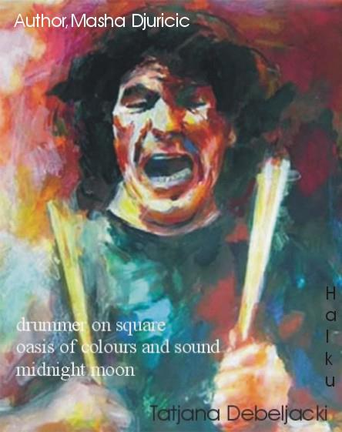

Image: Masha Djuričić
Haiku: Tatjana Debeljački

Rabija Mameledžija

pijano nebo
naginje se strmoglavo
stiže novo ljeto
a drunk sky
bends steeply
New Year coming

Hristina Pandjaridis
some flour from crackers and sweets
dissolves around me
and angels flying out of the oven
who replaced
the recipe
край мен лети брашно
от соленки и сладки
а от фурната излитат ангели
кой подмени
рецептата
translated by Diana Teneva

brašno keksa i kolačića
leti oko mene
i anđeli lete iz rerne
tko je zamijenio
recept

Donco Mishovski

ulazim srećan zaboraviću staru novu godinu

entering happy I’ll forget the old new year

Branka Vojinović-Jegdić

Nova godina –
sa pahuljama šaljem
najljepše želje

New Year’s Day –
with snowflakes sending you
the best wishes.

Daniela Vuković

Nova godina
kuca na naša vrata.
Polako, tiho...
S mirom i ljubavlju
primimo najmilije.

New Year
knocking at our door.
Slowly, silently...
Accepting our dear ones
in Peace and love

Pravat Kumar Padhy

New Year--
my wife rearranges sofa set
facing haiku calendar

Nova Godina –
supruga razmješta sjedeću garnituru
prema haiku kalendaru

Bruce Ross

power outage
in the motel courtyard
smiling snowman

nestanak struje
u dvorištu motela
nasmiješen snjegović

Vid Vukasović

U starom mlinu
Nova godina stiže
Izmeđ dva zrna

In an old mill
The New Year arrives
Between two grains

Translated by Saša Važić

Tatjana Debeljački

poguren starac
unuku nosi jelku
u gradu sipi sneg

bent old man
brings in the Christmas tree
snowing in the town

Translated by the author

Sonam Chhoki

cave temple —
skullcup* of New Year offering
smokes with frost

hram u špilji –
zdjela * Nove Godine nudi
dim s mrazom

*skull cup: (Sanskrit KAPALA) is a cup made of human skull and is used in Hindu and Buddhist rites.
posuda od ljudske lubanje, upotrebljava se prilikom Hindu i Budističkih rituala

Verica Živković

doček Nove godine –
posrtanje u praznoj sobi
sama

New Year’s Eve –
staggering around an empty room
alone
translated by the author

Dušan Đurišić

Nova godina,
čestitanja, poljupci,
pjesme, pokloni.
A ona usamljena
gleda u sliku sina.

New Year's day
greetings, kisses,
songs, presents.
Lonely she is gazing at
her son's photography.

Dubravka Borić, Hrvatska

Nova godina
vatromet dobrih želja
ukrašava svod

New Year’s Day
fireworks of good wishes
adorning the sky

Geert Verbeke

only two dogs
and a monk in the temple
Happy New Year

tek dva psa
i monah u hramu
Sretna Nova Godina
Robert Epstein
New Year's Day
my mother refreshes
her old complaints
Nova Godina
moja majka obnavlja
svoje stare poteškoće
Modern Haiku, 39.2, 2008
Tzetzka Ilieva
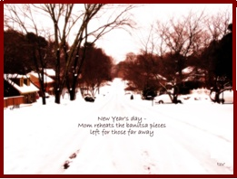
New Year’s day –
Mom reheats the bonitsa pieces
left for those far away

Nova Godina–
Mama podgrijava kolačiće
ostavljene za one koji su daleko
Ajaya Mahala
new year
my best greetings card
is anonymous
nova godina
moja najbolja čestitka
je anonimna

Eduard Tara, Romania

Year’s end –
the old suitcase still waiting
at the door

Sfârşit de an –
vechea valiză-aşteaptă
încă la uşă

original English by the author
Polish International Haiku Contest Poland, 2012, Commendation

Kraj godine –
stari kufer još čeka
pored vrata

Smajil Durmišević

kraj je godine,
svi se raduju – čemu,
ima li kraja?

the end of the year,
all of them rejoice - why,
is there an end at all?

Goran Radičević Risan

Hacu hinode.
Odlazi stara stiže Nova godina;
Sunce se rađa.

Haku hinode
the old year on the leave;
the sunrise.

Natalia Kuznetsova

a drunk Santa
caroling in full voice,
my dog all ears

pijan Djed mraz
pjeva božičnu pjesmu na sav glas,
moj se pas pretvorio u uho

Mainichi Shimbun, December 2013

Dragutin Pasarić

Na nebu zvezde
detešce v jaslami
pojdimo znova.

Stars in the sky,
an infant in the manger
let’s start from the beginning

Charishma Navneet Gupta

new year -
my resolutions soar
in a balloon

Nova Godina-
moje rezolucije lebde
u balonu

Chen-ou Liu

the new year begins
with the same rising sun...
me in the mirror

počinje Nova Godina
s istim izlazećim suncem…
ja u ogledalu

Anatoly Kudryavitsky

climbing cloud peaks
for the first time –
New Year's moon

Penjući se po vrhovima oblaka
po prvi put –
Novogodišnji mjesec
by Anatoly Kudryavitsky, from "Capering Moons", Doghouse Books).

Dennis Rhodes

On New Year's morning
I started out with a smile –
will keep it all year!

Novogodišnje jutro
započeh osmijehom –
zadržat ću ga cijelu godinu

Steliana Cristina Voicu

white dresses
in every show-window –
he promised me
he will return
until New Year

bijele haljine
u svakom izlogu –
obećao mi je
vratit će se
do Nove Godine

Ram Krishna Singh

locked between
my bed and quilt
new year chill

zaključana između
moje postelje i pokrivača
novogodišnja hladnoća

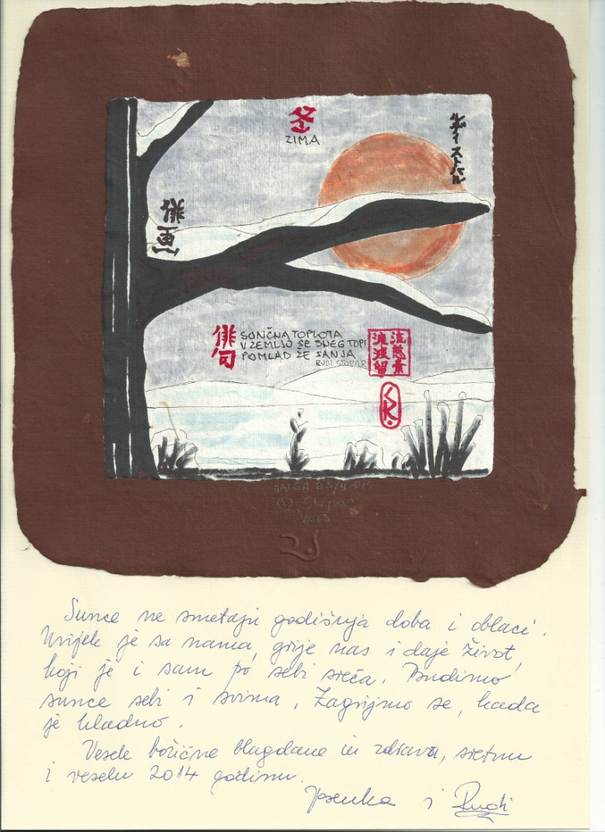Rudi Stopar

Danica Bartulović

kucnu ponoć
usne su crvene ruže
poljupci i darovi
mirijade sjajnih zvijezda
koja li je moja domovina

ticking midnight
lips are red roses
kisses and gifts
myriads of shiny stars
which one is my homeland

Heike Gewi

New Year’s sun
A sigh of relief
Skating starts

Novogodišnje sunce
Uzdah olakšanja
Počinje sezona klizanja

Malvina Mileta

Nova Godina i pas
dijele smrznutu kost
pod prozorom

New Year and a dog
sharing a frozen bone
under the window

Neal Whitman

leather-bound
handmade Italian journal
page one is blank
I make my first entry:
"I will write one line a day."

kožni omot
ručno uvezenog talijasnkog žurnala
prva stranica je prazna
zapisujem prvu odrednicu:
“Bilježiti ću jedan redak dnevno.”

Poornima Mathad

New year dawn
the champaks fragrance
of orange hopes

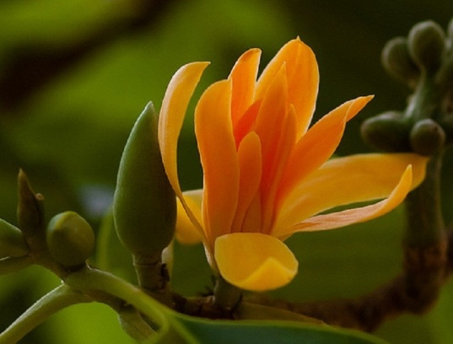

http://www.kupindo.com/Seme/16876369_Michelia-champaca
Novogodišnje svitanje
miris tropska zimzelene magnolije
narančastih nada

Charles Trumbull

New Year’s —
the cat yowls to go out
to come in

Frogpond 35:2 (winter 2012)

Nova godina —
mačka urliče sad bi napolje
pa unutra

Boris Nazansky

pauk na niti –
kraj božićnog čišćenja
donosi sreću

a spider on its thread–
end of Christmas cleaning
brings good luck

Saša Važić

novogodišnji mesec --
na trošnim stepenicama
još jedan sloj snega
new year moon -
on the crumbling front steps
another layer of snow

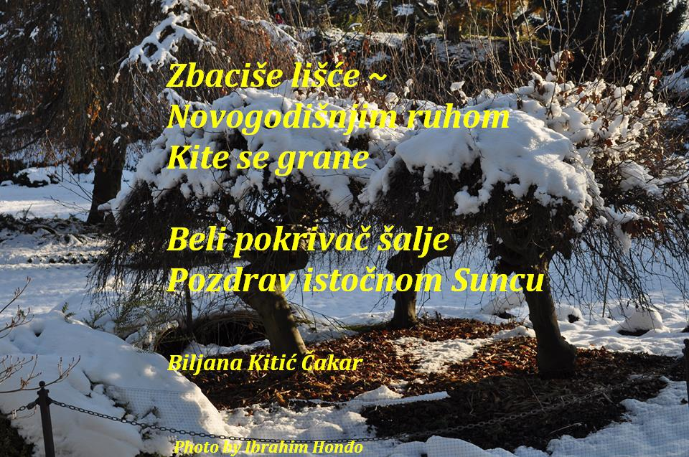
Photo: Ibrahim Honđo
Tanka: Biljana Kitić Čakar

Ivo Markulin
novogodišnji zvon
daleki prijatelji
odbrojavaju sa mnom

New Year’s bells
distant friends
countdown with me

Vladimir Devidé (1925-2010.)

Čestitar Nove
godine: i dimnjičar
bijelog lica!

New Year congratulations –
even the chimney-sweep
has a white face!

*
Novogodišnje
jutro. I gola stabla
sva u bjelini.

New Year’s morning.
Even the bare trees
are all in white!

Vladimir Devidé; Trenutak / The Moment, Nizovi, haiku sequences, Ceres Zagreb 1997.
Translated by the author

Stjepan Rožić
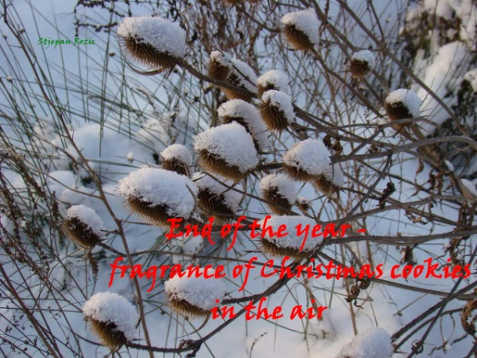
kraj godine-
miris božićnih kolačića
u zraku

end of the year–
fragrance of Christmas cookies
in the air

sketchbook No.6, 2011

SREBROM U PRAHU
JELKA PROCVJETALA
POD SRPOM ZLATNIM.
Blagoje Vujisić

Beverley George

the new year
begins with sky rockets
like them
who can tell
where we will land

empty garden 2006, reprinted 2013

nova godina
počinje s raketama
baš kao i one
tko zna
gdje ćemo se prizemljiti

Đurđa Vukelić Rožić

New Year
the Earth sneezes
fireworks
Nova Godina
Zemlja kiše
vatromete

http://www.asahi.com/english/haiku/
Asahi Shimbun, January 6, 2012

PR
DIOGEN pro culture magazine
http://www.diogenpro.com

