
The 23rd ITOEN “Oh-I Ocha” New Haiku Contest, Tokyo, Japan 2012

SPECIAL MERIT AWARD

with drops
of rain
a rain of petals

s kapljicama
kiše
kiša latica

Vera Primorac, Viškovo, Hrvatska
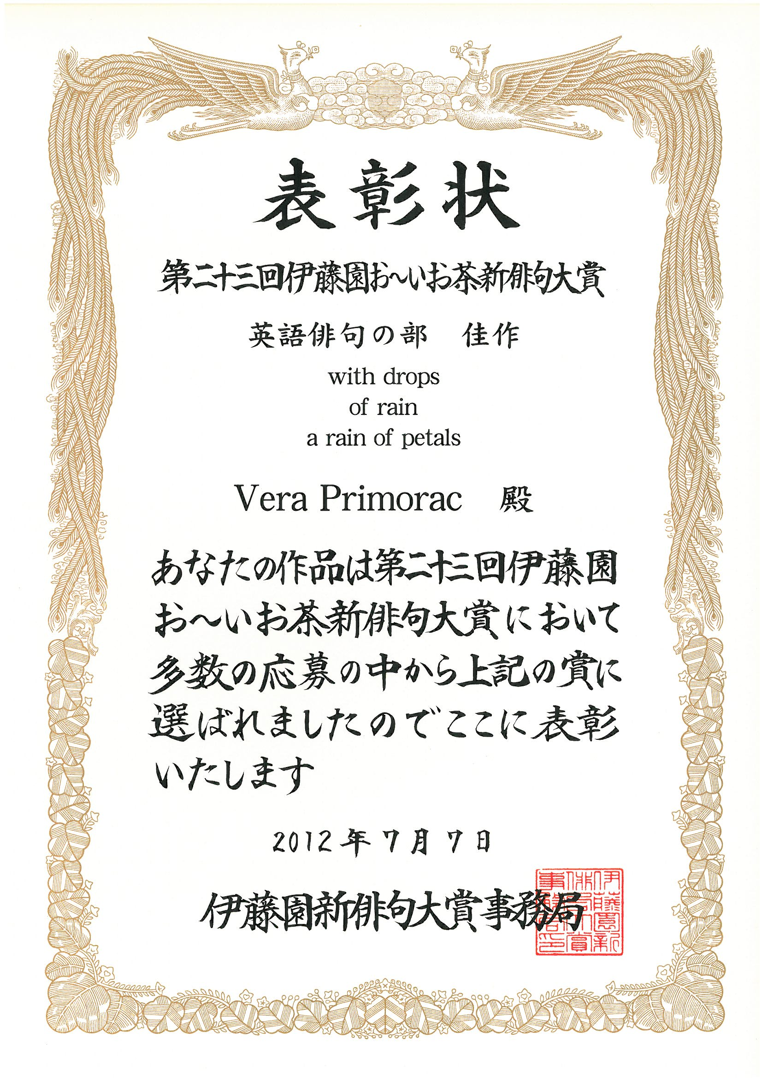

*

MERIT AWARD

on the lawn
in front of the concert hall
blackbirds’ concert

na travnjaku
ispred koncertne dvorane
koncert kosova

Živko Prodanović, Zagreb, Hrvatska


PR
DIOGEN pro kultura
http://diogen.weebly.com

