
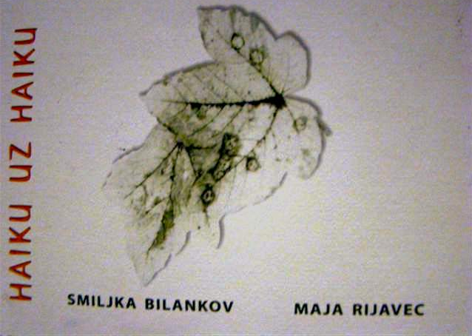

Smiljka Bilankov i Maja Rijavec
HAIKU UZ HAIKU
Gradska knjižnica Dugo Selo, 2011.
ISBN 978-953-7737-02-3


Haiku Smiljke Bilankov:

Za jatom ptica
skrenuh u drugu ulicu
i dođoh kući

Following the birds
I turned into another street
and came home.

*

Jedan crveni mak
među tračnicama
zaustavlja vlakove.

A red poppy
between the rails
stops the trains.

*

Usnuli kamenčić
potražio u školjki
skrovište.

Dreaming little stone
has found a shelter
in the shell.

*

Stara platana
polako ljušti koru
do čiste bjeline.

An old plane tree
slowly peeling off its bark
to pure whiteness.

*

Dva stara hrasta
udružila se
u jednu krošnju.

Two old oak trees
united
into one crown.

*

Rujansko veče
dan je kraći
za jednu planinu.

September evening
the day is shorter
for a mountain.

*

Ležim na žalu
u jednom uhu cvrčci
u drugom šum mora.

Lying on the beach
in one ear the crickets
on the other murmur of the sea.

*

Snježne pahulje
grubo lice muškarca
biva mekše.

Downy snowflakes
crude face of a man
being softer.



Haiku Maje Rijavec:

Cvrkut i trzaj
oprez lijevo-desno,
ode gladni ptić.

A chirp and a jerk,
right and left on the alert,
the hungry bird is gone.

*

Bijele sjene-
na bijelom polju tek obris
krilatog krika vrane.

Snow white shadows –
on white field just the outline of
crow's winged cry.

*

I puče vidik -
srebrnomodri ushit
prije imena

A sudden sight –
silvery-blue rapture
preceding its name!

*

Proljetno jutro-
nad izmaglicom lebde
duhovi voćaka.

Early spring morning –
phantoms of blossoming fruit trees
float above the haze.

*

Vlat: drhturi
granica lijevog i desnog
plavetnila.

A blade of grass.
The shivering border between
left and right skies.

*

Jučer smo plijevili-
kraj hrpe mrtvog korova
zasjao neven!

Morning after weeding –
new marigold blossoms shine
by heaps of dead plants.

*

Malen i zbunjen
moj javor stoji gol na
raskošnom sagu.

Small and confused
my maple-tree naked
on its gorgeous carpet.

*

Slikom vijuga
za neko oko staza,
za neko zmija.

Winding in the picture
to one's mind a pathway,
a snake to another's.

*

PR
DIOGEN pro kultura
http://diogen.weebly.com

