
Antonija Pedišić (1941-2010.)

BRODINA TOM

Polagano nas vozi TOM_TT Line po pučini do Švedske.

U plavetnilu
Srebri se odsjaj sunca
Svjetlo u moru

Na sedmoj palubi šećem sama u mnoštvu. Divan ljetni dan. Ja u vjetrovki a na Jadranu gori.

Suša i vjetar
Razdražili
Piromane

Daleko od tih problema, problema djece i prijatelja, ostvaruje mi se davna želja i sni za skitnjom za mene nepoznatim sjeverom Europe. Pet sati traje prijelaz s jedne obale Europe na drugu, iz Rostocka do Trelleborga. Ne čitam ništa iz bijelog papira samo iz plavetnila neba i mora. Vjetar mi lista misli i emocije. Odjednom na plavoj palubi nešto zablista: Gle! Poklon! Zlatnik! Jedan euro od čokolade! Izgubio ga sigurno u trku neki mali gusar. Sad je moj!

Slatko blago
Rastapa se u ustima
Ništa nije vječno

Udišem zrak pun kapljica mora s beskrajnog modrog oceana.

Na nama jedre
Sve krpice i kosa
Hihotanje djece

Pasem prazninu svemira i slušam kako stenje brodina Tom. Pa nije ni čudo. U utrobi mu mnoštvo autobusa, kamiona, najrazličitijih većih i manjih vozila ...

Na palubi
Seoba putnika iz
Hlada na sunce

Kako je prostrano nebo a pticama ni traga.
Kako se beskrajno more danas doima tako nevino.

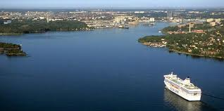

A SHIP TOM

Slowly, the ship Tom TT Line navigates, taking us over the open sea to Sweden.

In the blue
A silvery reflection of the sun
a light in the sea

On the seventh deck I'm walking alone in the crowd. A beautiful Summer day. I'm in a wind-proof jacket and the Adriatic is on fire.

Drought and the wind
Irritated
The pyromaniacs

Far away from these problems, the troubles of the children and friends, I have my old wish fulfilled, the dreams about wandering over North Europe, unknown to me yet. The crossing from one shore of Europe to the other, from Rostock to Trellerborg lasts five hours. I'm not reading anything from the white paper, but from the blueness of the sky and sea only! The wind lists my thoughts and emotions. Suddenly, on a blue deck something shining: Look! A present! A gold coin! 1 Euro made of chocolate! Some small pirate must have lost it while running about the deck. Now it belongs to me!

A sweet treasure
Melting in my mouth
Nothing lasts forever

I inhale the air full of the sea drops from the endless blue ocean.

Sailing on us
All the clothing and the hair
Children's laughter

I gaze at the emptiness of the space and listen to the Ship Tom's squawking. Nothing to wonder about, at all. In its interior are many coaches, lorries, different kinds of large or smaller vehicles...

On the deck
The move of the passengers from
The shade into the sun

How spacious is the sky yet without a sign of birds.
How the boundless sea appears so innocent today.

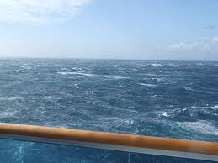

PR

DIOGEN pro kultura
хttp://diogen.weebly.com

MaxMinus magazin
хttp://maxminus.weebly.com

